The Ellan Vannin Maritime Centre
ROUND THE ISLAND RACE 2024
Sailing Instructions
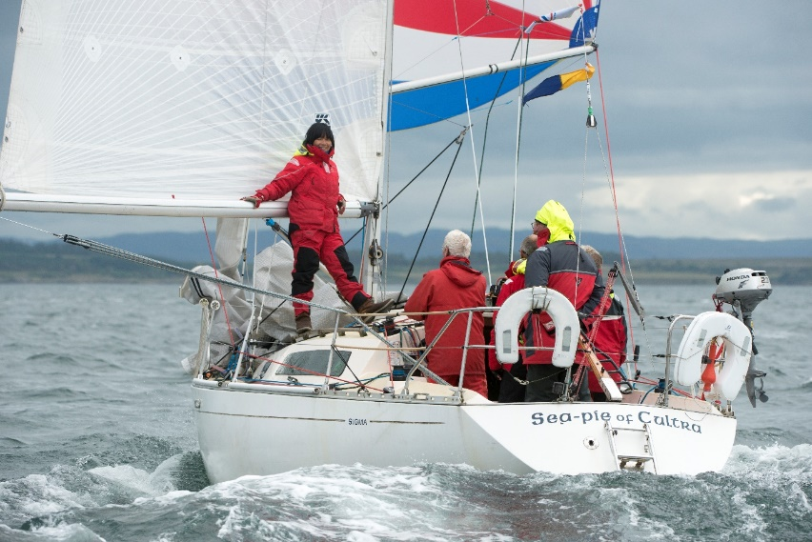
MANX SAILING & CRUISING CLUB
www.msandcc.org

COMMODORE’s WELCOME to the

Ellan Vannin Marina Round the Island Race
6th July 2024

A very warm welcome to the 72nd edition of the Manx Sailing and Cruising Club’s Round the Island
Race.
We are pleased to welcome on board a new sponsor for the Race, namely the Ellan Vannin Maritime
Centre. EVMC have put a great deal of effort into designing and promoting a new 400 berth 24 hour
marina in Ramsey adjacent to the Town Centre, featuring a large public park area, a professional
maritime training centre, lifeboat berth, sailing club, hotel, in-character housing and a wide range of
other facilities. Once this has been established, the plan is to substantially extend the racing and
cruising programmes including a Viking 600 race around the Hebrides and back to Oban, a Viking
Trail following the ancient routes South from Scandinavia through the Irish Sea and down to the
Canaries and a Celtic Cruise incorporating the West Coast of Scotland, Man, Wales, Ireland,
Cornwall, Brittany, Galicia and beyond. Many contacts have already been made with sailing
organisations in these places and there is much enthusiasm for the projects.
For this year’s race, a sociable start time of 1100 hrs will hopefully allow for a pleasant daylight trip
around the Isle of Man, with no end to astronomical twilight and a bright moon for all yachts to finish
during daylight or at least in a pleasant glow.
This will also mean crews can enjoy the usual MS&CC hospitality in the club house for longer on
Friday night!
Prize presentations will take place on Sunday July 7 th at approximately 1pm and I look forward to
Seeing you all there. The weekend coincides with Tynwald Day (July 5 th ) when visitors can take in our
national day celebrations.
A huge thanks goes to Brian Quayle and the Race committee for organising this event and to all the
members who provide support around the club house during the weekend.
I wish everyone an enjoyable weekend, fair winds and a safe race.

Jerry Colman, Commodore

PROGRAMME AND GENERAL INFORMATION
RACE HEADQUARTERS
The Race Oﬃce in the Sailing Club will be open on Friday July 5th from 18.00 hours to 23.00 hours. Oﬃcers of the Club will be available all day on Saturday. The Club is at the Lookout, South Promenade, Ramsey, near the root of the South Stone Pier. The Club telephone number is: 01624 813494/ 07624 496883
RACE COMMITTEE
The Race Committee will consist of:
Brian Quayle
Keith Poole
Andrew Dean (Principal Race Oﬃcer)
Jerry Colman
Helen Kee

Yachts are required to carry VHF RT. On Friday evening, Saturday morning and during ﬁnishing stages of the Race, a watch, which may not be continuous, will be kept on Channel 37. Competitors are reminded not to call the Coastguard on Race business, but see Sailing Instruction No. 12 (Retirements). Yachts will be expected to monitor Channel 16 as is usual. Isle of Man Coastguard are on: 01624 686624. Race Oﬃcer's contact number is 496883.
NUMERAL PENNANTS
The Race Committee has decided to drop the requirement for competitors to display numeral pennants.
TIDES
Yachts can enter and leave the Harbour approximately 2 ½ hours each side of High Water.
FRIDAY 5th July

High Water 11.41 hours and 24.02 hours BST. Club hours 17.00 to 23.00. Registration will take place on Friday (see below) late entries, sailing instructions etc. will be available. MS&CC IOM Sailing Directions and other items will also be on sale.. To ease congestion in the Outer Harbour the Bridge will be swung, as required, to allow yachts to pass through.

Skippers must register at the Race Oﬃce in the Sailing Club between 17.00 hours and 19.00 hours and collect their entry lists, sailing instructions, (if not already received), and late instructions. In exceptional circumstances, skippers unable to get to the Race Oﬃce because they are still at sea, should contact the Race Oﬃce by phone 813494 or VHF on channel 37(M1).

19.00 - Sponsor's Reception for Skippers and Crew with food and BBQ on the Club Forecourt.
SATURDAY 6th July
High water 12.28 hours BST
First start 11.00 hours BST and then as per schedule. Bridge swings as required.
SUNDAY 7th July
High water 00.38 hours BST and 13.03 hours BST.
All ﬁnishers must return their declarations, on the form in this booklet, to the Race Oﬃce. The Race will ﬁnish for all classes at 1100 hours BST. The prize giving is scheduled for 13.00 hours.

PRIZES
DIVISION I IRC
Overall Winner: Ramsey Town Cup and Prize
Class A: 1st I.O.M. Breweries Cup and Prize
DIVISION II NHC
Overall Winner: Coronation Cup and Prize
Class A: 1st Bancroft Trophy and Prize
Class B: 1st Shelagh Williams Trophy and Prize
Class C: 1st Quayle Tankard and Prize
DIVISION III
Overall: Winner Corrin Trophy
FIRST MONOHULL YACHT ON NHC OVERALL
Golden Jubilee Trophy and Prize
2nd Maddrell Trophy and Prize
(All yachts will be assigned an NHC number for this race by the Race Commi%ee)
RAMSEY COURIER CUP
First Yacht to ﬁnish on elapsed lime.
SIGMA 33 ONE DESIGN TROPHY
JOHN COPLAND TROPHY (to be awarded for endeavour)
MANX CUP
Best performance by a Manx entrant who is not a prize winner.
The presentation of this cup is at the discretion of the Race Committee.
ISLE OF MAN TIMES TROPHY
This is a Club Squadron Trophy. A Club Squadron shall consist of the three yachts of that club which score the most points for their club. All times shall be corrected limes. Points in each class will be calculated using the following formula:-
1 + 10 (Log N - Log P)
where, N equals the number of ﬁnishers
P equals the ﬁnishing position
A Squadron's aggregate points in all classes shall be totalled to ﬁnd the winning Squadron.
Other Prizes for various one design types of Yacht and for Old Gaffers if entries permit.
All entrants will be sent a results printout shortly after the Race.

Round the Island Race 2023: Award of Trophies
Trophy | Winning | Yacht Club | Owner
Ramsey Town Cup | Seapie of Cultra | MS&CC | J Colman
Coronation Cup | Not Awarded
Bancroft | Not awarded
Shelagh Williams | Not Awarded
Quayle Tankard | Not awarded
Corrin Trophy | Not awarded
Ramsey Courier Cup | LILEE | IOMYC | J Walker
Briggs | Not awarded
IOM Times | Not Awarded
John Copland Cup | Not Awarded
Sigma 33 Trophy | Seapie of Cultra | MS&CC | J Colman
Golden Jubilee Trophy | LILEE | IOMYC | J Walker
Madrell Trophy | Not awarded

Cut here

MANX SAILING AND CRUISING CLUB
THE IOM COPIERS
ROUND THE ISLAND RACE 2024
DECLARATION
I hereby declare that I am a member of the.....................................................................
Club and that I was on board and in charge of the Yacht ...............................................
........................................................................................................................................
while sailing in the above race and that during the race the I.S.A.F. racing rules, the R.Y.A. prescriptions and the Sailing Instructions were observed.
I estimate that I crossed the ﬁnishing line at..........................................................hours
..................................................minutes behind the Yacht ...........................................
..................................................and about ...................................................................
minutes ahead of the Yacht...........................................................................................
.............................................
signed

SAILING INSTRUCTIONS
1. RULES
The Race will be sailed under the current World Sailing Racing Rules together with the R.Y.A. Prescriptions, these Sailing Instructions and the Conditions of the Manx Sailing and Cruising Club for the 2024 Round the Island Race as set out on the Entry Form.
Time Allowances for Division I Yachts will be by IRC, TCC. Yachts in this division will also be assigned R.Y.A. N.H.C. numbers for the overall result. Time Allowances for Division II Yachts will be by R.Y.A. National Handicap for Cruisers (N.H.C) or as allocated by the Race Committee of the Manx Sailing and Cruising Club. Time Allowances for Division III Multihull Yachts will be by R.Y.A. N.H.C or as allocated by the Race Committee of the Manx Sailing and Cruising Club.
ELIGIBILITY
Yachts entering Division I must hold current IRC certiﬁcates and have SSS numbers of at least 15 or O.R.C. Category 4. IRC Yachts with SSSN greater than 15 must comply with MSCC safety equipment Regs. or ORC cat. 4. Copies of valid rating certiﬁcates must be presented at Race Oﬃce prior to start of Race.
Yachts shall be genuine cruising Yachts ﬁtted and sailed with proper precautions and carrying at least the required minimum safety equipment, described on the entry form and herein. Any above Yacht will be eligible for the Ramsey Courier Cup regardless of number of starters in her class. All yachts will be subject to checks on safety equipment.
NIGHT SAILING
Between the hours of 2141 BST on Saturday 6th July (Sunset) and 04.54 BST on Sunday 7th July (Sunrise), the above quoted rules shall be supplemented and when a conﬂict arises replaced by the requirements of the current International Regulations for the Prevention of Collisions at Sea.
2. COURSE
The Course shall be round the Isle of Man north about leaving the Calf of Man to Port. The distance is approximately 65 miles.
3. THE STARTING LINE
In Ramsey Bay. The starting line will be a line between the signal mast at the seaward end of the South Stone Pier and the outer limit buoy approximately due north of the end of the Queen's (Iron) Pier.
If the circumstances prevent the laying of the outer limit buoy, an alternative start line will be used. The use of the alternative start line will be indicated by code ﬂag "Z" ﬂown from the signal mast on the South Stone Pier from 0930 BST on Saturday until the completion of the starting signals.
SAILING INSTRUCTIONS (CONT)
The alternative starting line will be a line between the Queen's Pier Dolphin and the Signal Mast at the seaward end of the South Stone Pier. Yachts will Start by crossing this line from south to north. If the alternative start line as described herein is used then the alternative ﬁnishing line described in 5 below will also be used. If the alternative Start and ﬁnish lines are instituted by ﬂying Code Flag "Z" as described herein, they will apply to all divisions and classes in the Race.
4. STARTING SIGNALS
A warning hooter will sound 1 minute before each start and Flag P will be removed
(All times are BST)
Classes | 5 min Warning | Flag P | Start
Pennants 1,2 & 3: | 10.55 hours | 10.56 hours | 11.00 hours

5. FINISHING LINE
The ﬁnishing line will be in Ramsey Bay, across a line South to North between a buoy carrying a ﬂashing light at night approximately 500 yards oﬀ the South Stone Pier and the pole on the South Stone Pier, leaving the buoy to Starboard.
In the event of the alternative start line being used, indicated by Code Flag "Z" being displayed from the Signal Mast at the start, then the alternative ﬁnishing line will also be used. The alternative ﬁnishing line will be the same as the alternative starting line, between the Queen's Pier Dolphin and the Signal Mast at the seaward end of the South Stone Pier.
Yachts will ﬁnish by crossing this line from North East to South West. Yachts ﬁnishing around low water should be aware of running too close to shore into shallow water.
Competitors are asked to time their own ﬁnish as accurately as possible and note the Yachts ﬁnishing immediately in front and behind where possible.
FINISHING AT NIGHT
All yachts ﬁnishing during the hours of darkness should identify themselves to the OOD either by using VHF Marine Channel 37 or by illuminating their sail number or name dodger. Three short ﬂashes from the OOD will conﬁrm identiﬁcation to those not using VHF radio. Mobile phone contact: 07624 496883.
After ﬁnishing, yachts anchoring in Ramsey Bay are asked to display riding lights to avoid danger of collision with ﬁnishing yachts.
6. TIME LIMIT
The Race will ﬁnish for all competitors at 1100 hours BST on Sunday 7th July, except see paragraph 11.
7. RECALL
Recall sail No's will not be displayed. When a Yacht starts prematurely (OCS), a gun will be ﬁred as soon as possible after the starting signal and International Code Flag "X" will be broken out. General Recall as per current RYA/ISAF Rules. An announcement of sail numbers of yachts OCS may be given on VHF channel 37 shortly after the start.
8. REGISTRATION
Yachts must register with the Race Oﬃce - see Programme and General Information on Friday 6th July. Failure to do so may result in disqualiﬁcation. IRC boats which have not supplied copies of Rating Certiﬁcates valid for the Race MUST present them at Registration.
9. LATE ARRIVALS
A yacht unable TO SAIL into the vicinity of the starting line in time to be ready for the scheduled start of her class may use her engine to do so. Having reached the vicinity of the starting line she must lose way and stop, starting again after completing a 360 degree turn under sail. The engine SHALL NOT be used in the vicinity of the start line during the four minutes preparatory period. See note on Registration in Programme and General Information.
10. POSTPONEMENT
The International Answering Pendant "AP" hoisted alone with two guns means a ﬁfteen minute postponement of the scheduled starting time for all classes which have not already received their starting signal. This postponement may be extended for a further ﬁfteen minutes period by dipping and rehoisting with two more sound signals.
11. INDEFINITE POSTPONEMENT OR CANCELLATION
Flag "AP" hoisted on Signal Mast on South Stone Pier together with three sound signals. If the Race is to be restarted after an indeﬁnite postponement either the ﬁrst substitute code ﬂag will be displayed (until the next warning signal) and a single warning gun sounded indicating that the next start will take place ﬁfteen minutes after this signal, or the second substitute will be displayed (until the next warning signal) and two guns sounded indicating that the next start will take place 30 minutes after this signal. The time limit for all classes starting after an indeﬁnite postponement will be 24 hours from the time of the ﬁrst start after the postponement. In the event of cancellation, competitors will be informed on VHF 37.
12. RETIREMENTS
Your co-operation is vital to enable the Race Committee to account for all Yachts.
Retiring Yachts must either:
(a) Telephone Race Control on 01624 813494 or 07624 496883
(b) on reaching a Manx port, telephone Douglas Harbour Marine Operations Centre on 686628
(c) When retiring to a non-Manx port make VHF contact on Channel 16 or telephone Douglas
Harbour Oﬃce on 01624 686628
13. PROTESTS
Protests shall be in writing accompanied by a deposit of £10 and shall be lodged with an Oﬃcer of the Race Committee or the Finishing Oﬃcers at the seaward end of the South Stone Pier within 6 hours of the protesting Yacht's ﬁnishing time. Protesters should ensure that the time of submission of the protest is noted in writing on the protest by the Receiving Oﬃcer.
14. NUMBER OF STARTERS
Two yachts in each division to start or no race for that division, except that a single yacht in any division may race for the Ramsey Courier Cup (fastest elapsed time) and the Golden Jubilee Trophy (overall corrected time).
15. RULE INFRINGEMENTS
(a) If the Race committee consider that a breach of the rules has been committed it may impose a time penalty of either 5% or 10%, disqualify the yacht or recommend the Manx Sailing and Cruising Club refer the matter to the RYA for action under World Sailing. Racing Rule 71.
(b) If a yacht incurs a time penalty under this regulation and subsequently might qualify for a prize based on elapsed times, her elapsed time shall be increased by the same percentage as under (a) previously before deciding whether she has won that prize.
16. DECLARATION
A tear-out declaration appears in these sailing instructions. It is required from each yacht and must be returned to the Race Oﬃce, posted through the Club letter box or placed behind the Club Bar. Failure to return this form may result in disqualiﬁcation.
JOIN THE MANX SAILING
& CRUISING CLUB

Full/Joint Members £69/ £111 p.a.
Junior (with parent) Members £27/ (£11) p.a.
For further Information log on to: www.msandcc.org

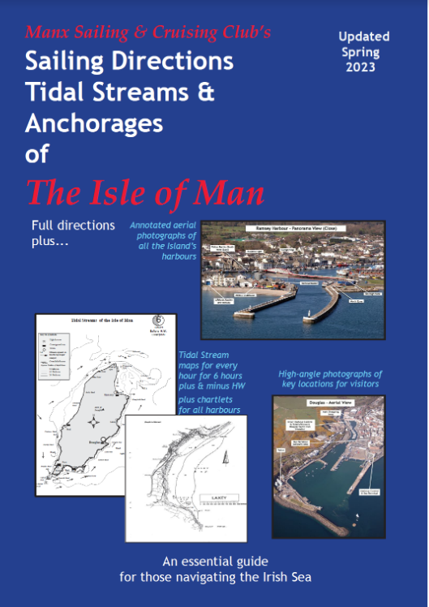

2023 Sailing Directions on Heavy Duty Paper £38.00.
Available from the Club Bar

